Verification and Testing Report

1. Preliminary Codebase Examination

A. Dead Code

Initial examination reveals three dead functions; “validate_priority”, “format_task_for_display”, and “calculate_workload”. A comment in “validate_priority” informs the user about this.

“flask.render_template_string” is imported but never used.

To prevent this in the future, pylint could be incorporated. Pylint scanning could be carried out automatically in the CI/CD pipeline to catch and prune or integrate dead code before deployment.

B. Query Inconsistencies

The codebase contains inconsistent SQL queries. The “login” function uses string formatting in its query:
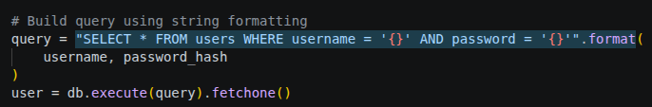
, which is insecure, while the “get_task” function uses context-appropriate parameterised queries:
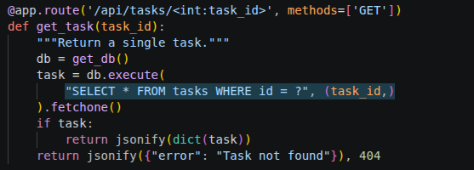

.

One other place where string formatting is being used in place of parameterised queries is the “search_tasks” function.

To patch this, all queries should move away from string formatting, instead opting for parameterised queries.

To prevent this type of inconsistency in the future, an SQL injection scanner could be implemented. By iterating over each POST endpoint and attempting controlled injection payloads, such inconsistencies could be caught early and before deployment. This is vital because relying on string formatting carries the risk of irreversible and complete data loss.

Additionally, to secure the database against the risk of data loss, backups should be made periodically, and a roll-back tool should be incorporated to allow for remote restoration of data.

C. Input Validation Inconsistencies
Input validation inconsistencies were also found. The “create_task” function validates input properly:

, while “update_task” does not:
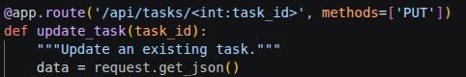

One other example of this is the “add_comment” function, where input is not being validated either.

To prevent this in the future, all endpoints should validate input data types and return appropriate HTTP error codes for invalid input. To test for such inconsistencies, an enumeration tool could be developed and integrated.

D. Error-Handling Inconsistencies

Error-handling inconsistencies were found as well. Some functions like “get_task” incorporate proper error handling:
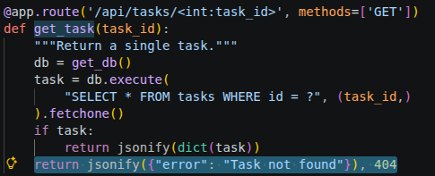

, while other functions like “delete_task” do not:
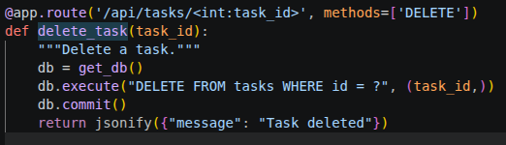

(Existence of record is never verified before deletion attempt – This fails silently).

This quality issue could be prevented by including error handling in each CRUD (Create, Read, Update, Delete) operation. Unit tests should be written to test for known failure points. Execution of said unit tests could be automated in the CI/CD pipeline to catch such inconsistencies before deployment.
E. Authentication Inconsistencies

Authentication only exists at the /login endpoint. No other endpoint requires it. This effectively makes authentication a feature rather than a system-wide integration.

This quality issue could be prevented by integrating authentication system-wide.

One implementation is to rely on sessions. Each login should generate a unique and time-limited session token. This token should be hashed saved in user’s cookies. Then, each function that requires authentication may access the token from the payload and compare it against the active sessions table. If it matches, authentication is successful, if not, an appropriate error is returned along redirecting the user to the login portal.

Integration could be tested automatically with an enumeration script that navigates to each endpoint without appropriate permissions.

F. No Database Error Handling

Across the entire file, not one database call includes error handling. If an error was to occur in a “db.execute” call, the application would fail, and data could be lost.

To patch this, try-except blocks should be implemented in each database call block, and appropriate HTTP error responses should be returned. Additionally, form input validation should be incorporated to prevent the user from being able to submit obviously wrong data.

G. Poor Deliverable Management

I identified two specific instances in the codebase where better deliverable management would have directly improved quality.

The first instance is the aforementioned utility function “validate_priority”. It was planned for, implemented, but never integrated. This (as well as the comment) is a clear sign of poor deliverable management. The task should have necessitated integration of this function instead of splitting the task into two separate tickets. Additionally, a definition of done should have demanded that the function is being called and works as planned.

The second instance is the “login” function. In it, the query is formatted using string formatting. This is inconsistent with other functions, and a clear sign of a poor deliverable management. The acceptance criteria for the ticket should’ve demanded that the function uses parameterised queries instead.

H. Effective Deliverable Management

There are numerous benefits to effective deliverable management; both to the development team as well as the end users.

For developers, it helps reduce workload and deliver features quicker and more robustly. It also minimises the need for reworks or refactors. For example, if the task for the function “validate_priority” had been planned out properly, the function could’ve been implemented and integrated in a single ticket, by a single developer.

Similarly, since the function “login” has been implemented poorly, it now requires a refactor, which vastly increases the workload – both for the original developer, as well as the reviewer.

For end users, effective deliverable management makes the software more reliable, consistent, and trustworthy. For example, the function “get_task” works as intended, while “delete_task” silently fails. This is a clear inconsistency which makes the software less reliable. When a user encounters this issue, they may lose trust in the product.

2. Verification and Testing

A. Unit Testing

Unit tests on 3 separate endpoints were conducted; “/api/login”, “/api/tasks”, “/api/tasks/<id>”. Following are the rationale behind the tests.

First, a test of the “/login” endpoint was conducted due to the fact that the development team is currently integrating authentication. To ensure that the implemented function can safely be integrated, the “/login” endpoint must be evaluated and proven to work, i.e. that you can log in.

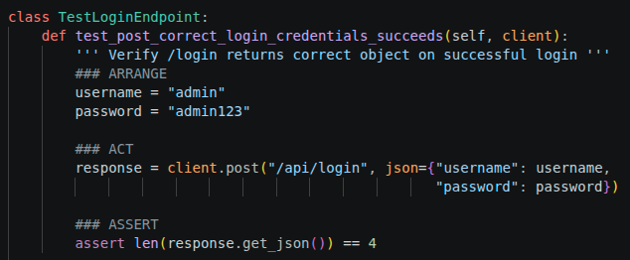
Next, a test was conducted to ensure that incorrect credentials are met with an appropriate error response. This is important as this proves that “/api/login” endpoint carries out actual authentication instead of just responding with 201.
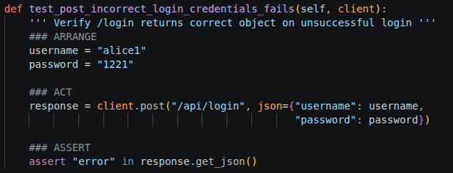
Lastly, a boundary test was conducted to ensure that the input behaves predictably. This test sends the correct data type, but incorrect values. This is important because incorrect values like these could cause the server to crash if not handled correctly.

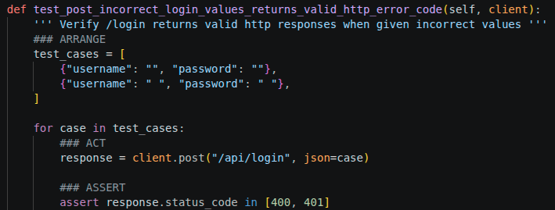
Second, the “/api/tasks” endpoint was tested in context of creating new tasks (POST as opposed to GET). This is the core functionality of this application so it needs to function properly. Correctly formatted payloads must respond with 201, while incorrectly formatted payloads need to fail safely. If this feature were to not work, all other features (like task retrieval) will fail as well.

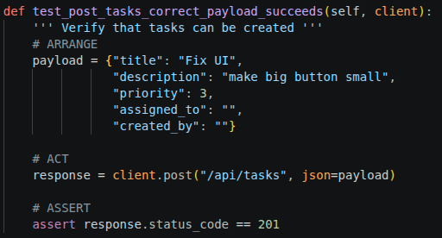

Similarly to testing correctly formatted payloads, incorrectly formatted payloads we tested to ensure that blank tasks are not being created. If they were, it could lead to indexing problems and the loss of sequence of id’s.

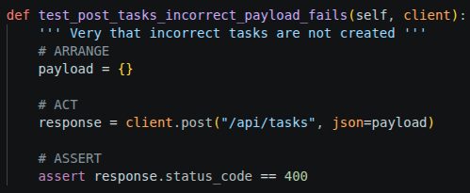

Extreme values were tested to verify whether values are being filtered. It’s important to filter obviously incorrect values, as neglecting to do so could lead to vulnerabilities, exploits, and worsened readability.

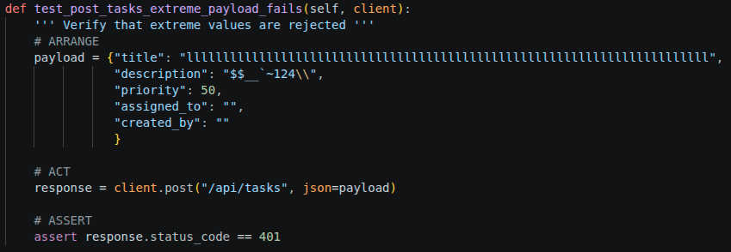

Lastly, the “/api/tasks/<id>”:

Similarly to creating tasks, retrieving tasks is of equal importance. It’s a core functionality of this application, which necessitates a unit test. This test proves that tasks with known correct ID can be retrieved.

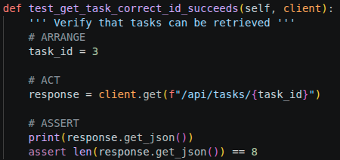

This test proves that incorrect IDs are met with appropriate error code responses.

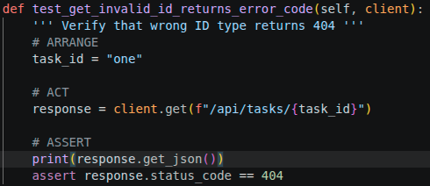

This test ensures that IDs at the edges of available range are retrievable.

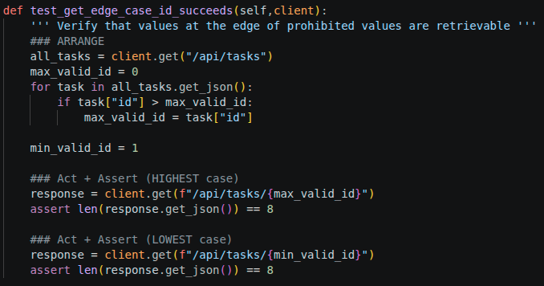
These tests were chosen to test the core functionalities of the API. The functions being tested constitute the very core of the application. If they were to fail silently, the whole application would break. As such, they are the most appropriate tests to be written at this point in time.

B. Integration Testing

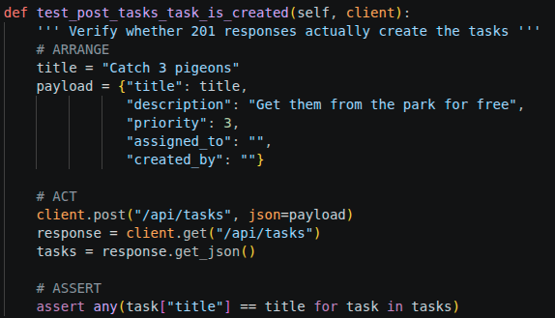
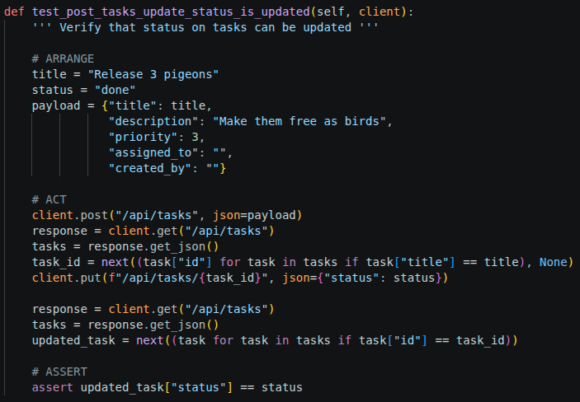

The unit tests written earlier don’t actually verify the results of their operations. Unit tests in principle only test that a given unit responsible for a given piece of functionality functions as expected, e.g. that the function “create_task” responds with the status code 201 when given correct payload.

To address this blind spot, integration tests are used instead. By using an integration test, we can test integrations between multiple units in to verify a given behaviour is true, e.g. that “create_task” actually inserts the new record into the database, and that “get_tasks” actually detects that change.

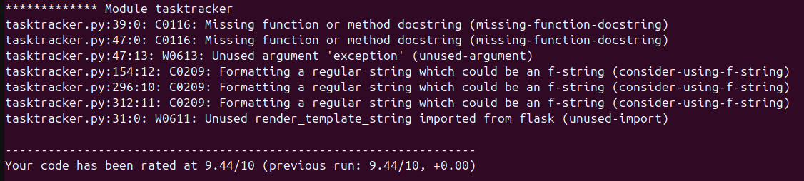

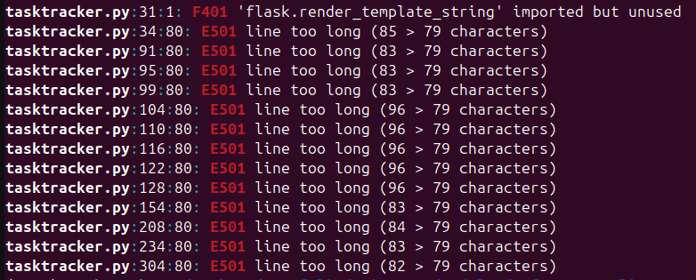

C. Non-Execution Verification

The provided script was linted using 2 separate linting libraries; Pylint and flake8. Each returned slightly different results with a single overlap between them.

Style Violations
- E501 – This is a flake8 style violation.
  - This means that the specified line of code exceeded the recommended length limit of 79 characters.
- C0116: Missing function or method docstring (missing-function-docstring)
  - This means that the specified function has no docstring; the comment written as a string directly below the function’s definition.
- C0209: Formatting a regular string which could be an f-string (consider-using-f-string)
  - This means that the specified line of code uses the old string formatting syntax; “ ‘Hello {}’.format(name) instead of f’Hello {name}’ ”.

Potential Bugs
- F401 'flask.render_template_string' imported but unused
- W0613: Unused argument 'exception' (unused-argument)
  - This means that a function takes an argument (named “exception”) but never uses it.

All of these would’ve gone uncaught if relying on unit testing or integration testing alone. This showcases the utility of non-execution verification. It is used for identifying issues in the code’s structure, style, and potential logic problems without requiring the program to be executed, allowing developers to catch maintainability issues, dead code, and hidden bugs early in the development process before runtime testing is performed.

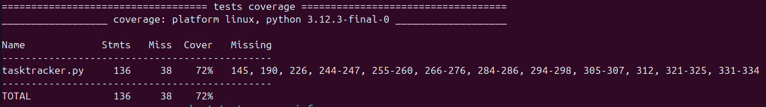

D. Test Coverage

The tests cover 72% of the code. Missing lines include 145, 190, 226, 244-247, 255-260, 266-276, 284-286, 294-298, 305-307, 312, 321-325, 331-334.

To see why some of the lines are missing, consider the following example:

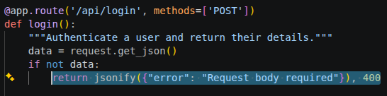

While the login function itself is covered, this particular exit from it is not. This means that during testing (both unit and integration), this function never returned the status code 400 – i.e. It never exited with that particular error.

The risks of uncovered code are unknown and hard to quantify. Uncovered sections may contain hidden logic errors, edge-case failures, or other unintended behaviours that were never tested for or addressed. Such errors could only be revealed in production, potentially leading to crashes. If a new developer was to modify an uncovered function, they would lack the insight of how that code behaves under different inputs, making refactoring significantly more dangerous.

Achieving 100% coverage is not always realistic or desirable for this codebase. Some endpoints or rarely triggered conditions may be difficult to reproduce without adding complexity and overhead. Instead of trying to achieve 100% coverage, it is much more advisable to maximise meaningful coverage.

E. TDD / BDD

Creating new tasks could have been developed differently using TDD (Test-Driven Development). Currently, the biggest problem with the function is that it does not filter out incorrectly structured payloads or payloads containing incorrect values. It simply returns 201 status code without applying the changes. Instead of creating the feature first, it could’ve been done the following way:

Once the piece of functionality is planned, a test for it could be devised. You could gather all the ways in which the feature could fail, and then write tests that incorporate those failures, i.e. Aim to trigger them. Once the test is complete, a ticket for the feature could’ve been created with acceptance criteria that demand the function only returns a success response when the input payload is correctly structured and contains valid values, and otherwise returns an appropriate error response without carrying out any changes. From there, the implementation could be written specifically to satisfy those test cases.

3. Efficiency Evaluation

Currently, all 14 tests complete within 0.51 seconds. This is perfectly acceptable for a CI/CD pipeline that runs on every commit and where speed and efficiency is of the essence. If the test suite was to grow to a 1000 tests, the estimated time it would have taken to complete them would have rose to around 36 seconds – Much less acceptable. In such a case, efficiency would need to be improved. This could be done by either pruning tests (not recommended), or by optimising the test execution strategy, for example, by grouping tests into “slow” and “fast” categories, and only executing the fast tests on every commit, while the slow tests could run periodically or on every merge.

